Entity classes usually related:

* One-to-one: Exactly one instance of A mapping to exactly one instance of entity B, and vice versa. Example.. a car has exactly one steering wheel, and a steering wheel one car.
* One-to-many. In this case, one instance of entity A maps to 0 or more instances of entity B. A single instance of entity B then maps to a single instance of A. I.e. A course is taught on a given semester. The given semester has many courses.. but each course instance only belongs to one interface.
* Many-to-many: Most flexible.. entity A related to 0 or more instances of entity B and vice versa.

In SQL, means either.. table to connect entities or a foreign key in one table..

**Entity Framework relationships**

One to one can be specified using **virtual** keyword.. for entities of type B..

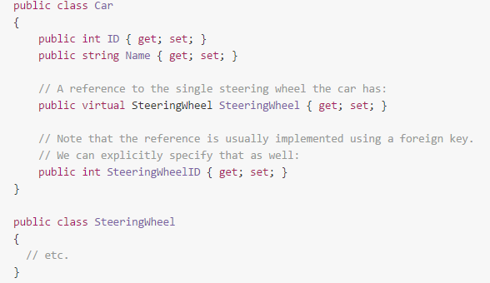

One-to-many:

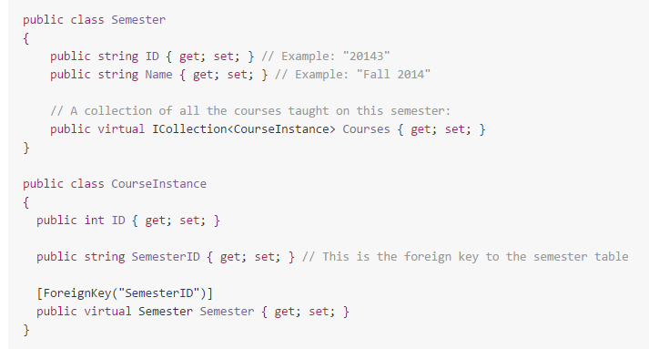

**Loading Ooptions**

* **Lazy Loading**. Related entities are loaded ONLY WHEN REQUESTED
* **Eager loading**. Related entities loaded **AT THE SAME TIME AS MAIN ENTITY**
* **Explicit loading.** We state EXPLICITLY how we want loading to occur.

Lazy loading could result in multiple queries for the database when one would suffice..